**Practical 9: Design a webpage to display the use of LINQ.**

**📌 Steps to Implement**

1. **Create an ASP.NET Web Forms project** in Visual Studio.
2. **Use LINQ to query a list of employees** (In-Memory Collection).
3. **Bind the LINQ results to a GridView** for display.

**1️ Create ASP.NET Web Form (WebForm1.aspx)**

Modify WebForm1.aspx to include a **Button** to fetch employee data and a **GridView** to display the results.

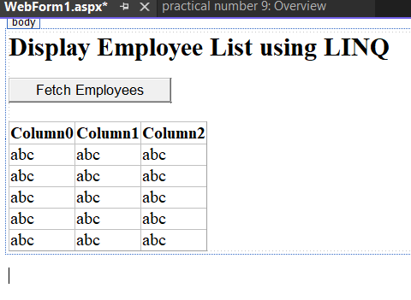

<%@ Page Language="C#" AutoEventWireup="true" CodeBehind="WebForm1.aspx.cs" Inherits="practical_number_9.WebForm1" %>

<!DOCTYPE html>

<html lang="en">

<head runat="server">

<title>LINQ Demo</title>

</head>

<body>

<form id="form1" runat="server">

<div>

<h2>Display Employee List using LINQ</h2>

<asp:Button ID="btnFetchData" runat="server" Text="Fetch Employees" OnClick="btnFetchData_Click"/>

<br /><br />

<asp:GridView ID="gvEmployees" runat="server" AutoGenerateColumns="True"></asp:GridView>

</div>

</form>

</body>

</html>

**2️ Backend Code (Default.aspx.cs)**

Modify WebForm1.aspx.cs to **use LINQ to query employee data**.

using System;

using System.Collections.Generic;

using System.Linq;

using System.Web.UI;

namespace practical_number_9

{

public partial class WebForm1 : System.Web.UI.Page

{// Define an Employee class

public class Employee

{

public int EmpID { get; set; }

public string Name { get; set; }

public string Department { get; set; }

public decimal Salary { get; set; }

}

// Sample Employee Data (In-Memory Collection)

private List<Employee> employees = new List<Employee>

{

new Employee { EmpID = 1, Name = "John Doe", Department = "IT", Salary = 60000 },

new Employee { EmpID = 2, Name = "Jane Smith", Department = "HR", Salary = 55000 },

new Employee { EmpID = 3, Name = "Mike Johnson", Department = "IT", Salary = 65000 },

new Employee { EmpID = 4, Name = "Emily Davis", Department = "Finance", Salary = 70000 }

};

protected void Page_Load(object sender, EventArgs e)

{

}

protected void btnFetchData_Click(object sender, EventArgs e)

{

// Use LINQ to fetch IT department employees with salary > 60,000

var result = from emp in employees

where emp.Department == "IT" && emp.Salary > 60000

select emp;

// Bind data to GridView

gvEmployees.DataSource = result.ToList();

gvEmployees.DataBind();

}

}

}

